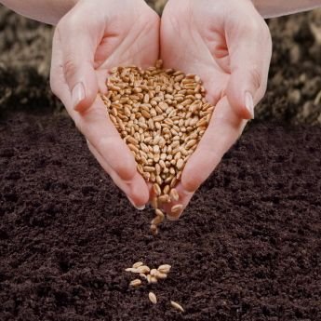

Seed Grant Opportunity
New York State Department of Health, through the Hunger Prevention and Nutrition Assistance Program (HPNAP) has provided Long Island Cares, -The Harry Chapin Food Bank with funding for organizations for Seed Grants. Since this is a HPNAP funded grant, projects should incorporate both nutrition and hunger relief. You do not have to be a HPNAP agency to be eligible for Seed Grant funding.

What is a Seed Grant?
Seed Grants are start-up grants intended to be used as a “seed” to begin a new or enhanced service to an agency or Emergency Food Relief Organization (EFRO). Seed Grants encourage the development of projects that support innovative ways of confronting emergency food and/or nutrition needs of low-income people.

Seed Grant Fundable Proposals include the following categories.

- Resource Enhancement and Community Partnership-projects that increase or enhance emergency food resources or create a diversified resource base through community partnerships, such as utilizing or developing Farmers Markets; growers, community gardens, or other resources.
- Organizational Capacity and Effectiveness - projects that increase organizational capacity and effectiveness to provide emergency food services and access to healthy foods.
- Linkage to Services – projects that can link emergency food providers and their guests to services that could reduce dependence on emergency foods. Examples include projects to expand outreach referral services to connect at risk individuals to medical care and social services and technology to develop training programs for at risk individuals to create linkages and increase skills for future job placement.

Workshop attendance is recommended for this grant.
If you are interested to apply for the Seed Grant, Long Island Cares, Inc.-The Harry Chapin Food Bank is having a Seed Grant Writing Workshop, Presented by Robin Amato, Chief Development Officer on Thursday, January 25, 2018 at 9:30am at 10 Davids Drive, Hauppauge, NY 11788
RSVP:cramsey@licares.org or call (631) 582-3663ext. 100

Seed Grant Applications are due Monday, February 26, 2018.

