Nutrition, Cooking & Food Safety Workshop Registration

FOOD SAFETY AND SANITATION CERTIFICATE WORKSHOPS
Thursday December 7th, 2017 1:30p-3:30p– Hauppauge only (Suffolk Location)
EXPIRED FOODS - “To serve or not to serve”
Wednesday, February 7th, 2018 10:00a – 12:00p- LIC Freeport location
Wednesday, February 7th, 2018 2:00p – 4:00p- LIC Hauppauge location

COOKSTOCK COOKING SKILLS & NUTRITION EDUCATION CERTIFICATE WORKSHOPS TAUGHT BY OUR ON STAFF DIETITIAN & HEALTHY FOOD CHEF… Laura Lynn Iacono MS, RD
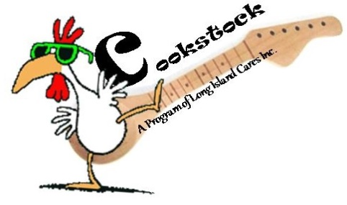

Friday, December 15th, 2017 11:00a-1:00p
– Hauppauge Kitchen Studio
“Fresh and Easy Healthy Holiday Sides!” Come and learn how to educate your food pantry, shelter and soup kitchen clients about “Mindful” healthy food preparation and eating during this holiday season.

Thursday, January 18th, 2017 9:30a-11:30a
– Hauppauge Kitchen Studio
“Builld a Betta Breakfast!” Come and learn how to be more culturally sensitive to your clients food needs, preferences and why breakfast is one of the most important meals of the day and how to incorporate different varieties of foods from all nations including but not limited to traditional and non- traditional breakfast grains, proteins, fruits, vegetables, dairy and Vegan foods in the morning.

Wednesday, February 14th, 2017 2:00p-4:00p– Hauppauge Kitchen Studio
“Soup it Up!” Do your part and take care of your heart by learning why and how preparing your own fresh homemade soup and stock pots can not only taste better but be better for your health and your emergency food recipients in lowering blood pressure, stress and reducing the risk of heart disease.

All of our workshops are free of charge and open to our network, agency members, Long Island Cares staff, volunteers and directors.

Fill out our workshop registration form below…

This form can be found in our agency newsletter & on our website…
http://www.licares.org/agency-support/nutrition-resources-and-recipes/
PRE-REGISTRATION IS REQUIRED for the above workshops. Please check the workshop(s) box(s) of your choice and complete the form below:
Agency Name: _________________________________________________ID#:____________
Address:_____________________________________________________________________
Phone:___________________ Email:_______________________________________________
Course Date & Description:________________________________________________________

Name of Attendee (s) (2 person maximum per registration form):
1.__________________________ 2._________________________________
There is no cost or fee to any of our member agencies for these classes.
Two ways to register for the above workshops; Fax or Email below…
via Fax form to: (631)-273-1375 OR Email this completed form to: lliacono@licares.org

