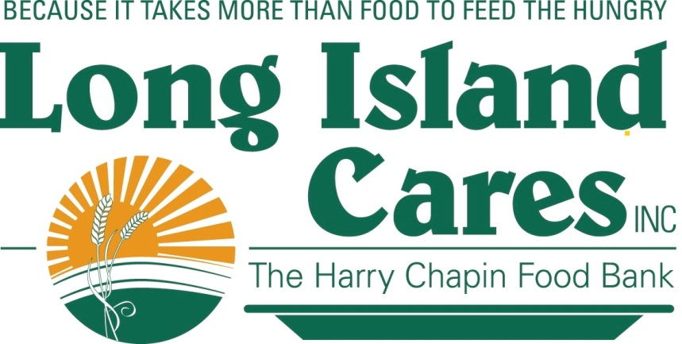
COME HAVE BREAKFAST WITH US ON
THE ASPARAGUS BREAKFAST FOOD TRUCK

Long Island Cares, Inc. – The Harry Chapin Food Bank will be providing ready-to-eat breakfast items to children at the following location:
Saturday, October 1: Family Service League - 801 Crooked Hill Road, Brentwood
Sunday, October 2: Westbury Divine Congregation, 911 Brush Hollow Road, Westbury
Sunday, October 8: New Life Ministries, 167 S. Fulton Street, Hempstead
Saturday, October 15: Wyandanch Community Resource Center, 1585 Straight Path, Wyandanch
Sunday, October 16: Glory House, 145 Stewart Avenue, Hempstead
Friday, October 21: St. Sylvester Church, 99 Robinson Avenue, Medford
Saturday, October 22: New Covenant, 12 Caleb's Path, Brentwood
Saturday, October 22: Westbury Gospel Tabernacle, 979 Prospect Avenue, Westbury
Sunday, October 23: HELP Suffolk, 685 Brookhaven Avenue, Bellport

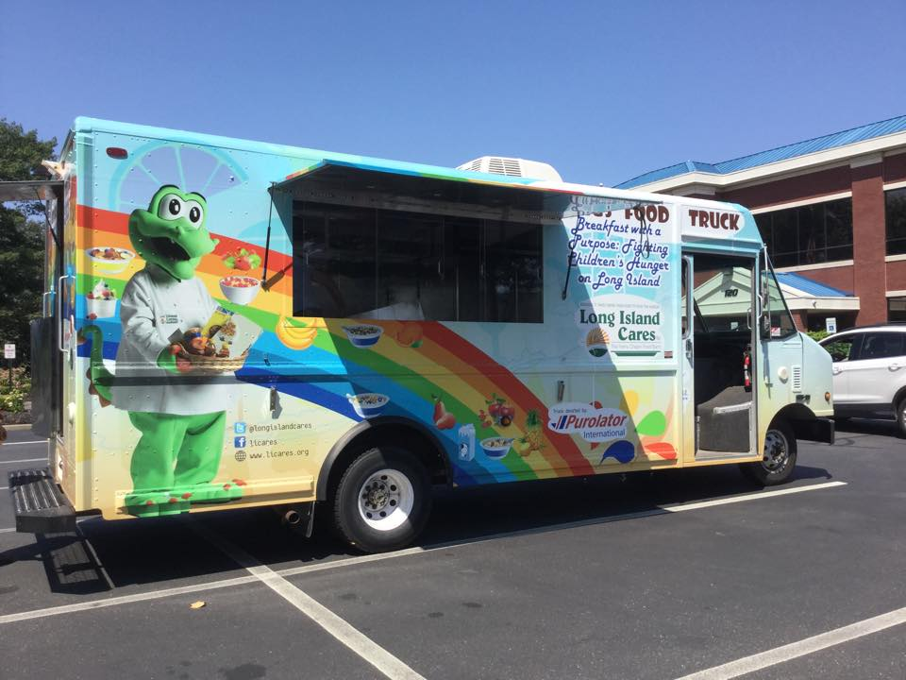
Breakfast is the most important meal of the day. Long Island Cares is dedicated to make sure that every child starts their day out with a healthy breakfast EVERYDAY.

ALL CHILDREN ARE WELCOME

