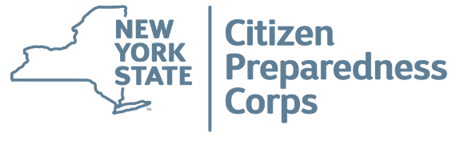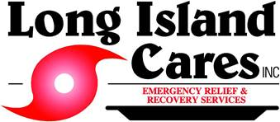

**SEPTEMBER IS NATIONAL PREPAREDNESS MONTH**

**Long Island Cares p*resents***

**NYS Citizens Preparedness Workshop**

Andrew Cuomo's Citizen Preparedness Corps gives residents the knowledge and tools to prepare for emergencies and disasters, respond accordingly, and recover as quickly as possible to pre-disaster conditions.

The program was designed by DHSES and covers a broad range of emergency preparedness topics, like developing a family emergency plan, stocking up on emergency supplies, and registering for NY-Alert, the free statewide emergency alert system. Participants will receive a training certificate and a wallet-sized "Z-Card" with emergency preparedness information.

**Join Us**

***When:* Wednesday, September 5, 2018**

***Where:* Long Island Cares Training Room**

**10 Davids Drive, Hauppauge**

***Time:* 10 a.m. – 12 p.m.**

**Registration Online:**

<https://www.cognitoforms.com/LongIslandCares2/LongIslandCaresCitizensPreparednessWorkshop>

Or,

**Call or Email & Questions:**

[lmowens@licares.org](mailto:lmowens@licares.org)

Contact: Lisa M. Owens 631-991-8107