WHERE TO GO FOR A THANKSGIVING MEAL 2017

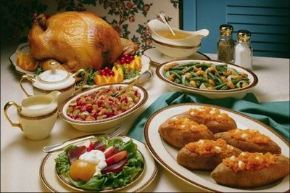
Our WarmesT Wishes for a
HAPPY THANKSGIVING
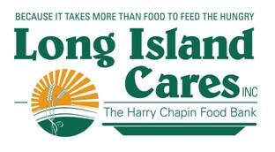
NASSAU COUNTY – Thanksgiving Meals 2017
Name of Agency Address Phone # Day & Time

- Home Mission S/K Naomi Temple A.M.E. Zion Church (516) 623-9340 Saturday, November 18
59 Babylon Turnpike Serving Time: Noon
Roosevelt, NY 11575

- Outreach COGIC S/K 226 Lawrence Ave. N/A Saturday, November 18
Lawrence, NY 11559 Serving Time: Noon

- Ebenezer SDA Church 97 Broadway N/A Sunday, November 19
Freeport, NY 11520 Serving Time: 1:00

- Hope for the Future Mobile S/K Hempstead Train Station (516) 752-5771 Wednesday, November 22
Hempstead, NY Serving Time: 1:00

- Faith Mission S/K Pope Francis Hospitality Center (516) 992-5063 Thursday, November 23
1510 DePaul St. Serving Time: 11:30
Elmont, NY 11003

- First Baptist Church of Westbury 212 Rev. Stanley Hines & Garden Sts. (516) 333-6668 Thursday, November 23
Westbury, NY 11590 Serving Time: Noon

- Harvest for the World S/K 90 Pleasant Ave. (516) 623-4498 Thursday, November 23 Roosevelt, NY 11575 Serving Time: 1:00

- Long Beach Food & Friendship INN 140 West Pine St. (516) 355-6209 Thursday, November 23
Long Beach, NY 11561 Serving Time: 11:45

- Ladles of Hope, Inc. 65 Atlantic Ave. (516) 378-0665 Saturday, November 25
Hempstead, NY 11550 Serving Time: 11:00

SUFFOLK COUNTY - Thanksgiving Meals 2017
Agency Address Phone # Day & Time
1. St. Gerard Majella Stewardship 300 Terryville Road (631) 473-2900 Thursday, November 16 Port Jeff Station, NY 11776 Serving Time: 5:30
- Shepherds INN S/K St. Joseph’s Carew Hall N/A Friday, November 17
45 Church St. Serving Time: 5:30
Ronkonkoma, NY 11779

- Hospitality Too S/K St. Anne’s Church (631) 482-8538 Saturday, November 18
88 Second Ave. Serving Time: 11:00
Brentwood, NY 11717

- Holy Church of Christ 41 Sage St. (631) 234-6799 Sunday, November 19
Central Islip, NY 11722 Serving Time: 2:00

- Our Daily Bread S/K St. James Church (631) 941-4141 Sunday, November 19
429 Route 25A Serving Time: 1:30
Setauket, NY 11733

- Nourish Babylon Christ Episcopal Church (631) 661-5757 Monday, November 20
12 Prospect St. Serving Time: 5:00
Babylon, NY 11702
- Having Friends INN Sayville Congregation United N/A Tuesday, November 21
131 Middle Rd. Serving Time: 5:30
Sayville, NY 11782

- Bethany Hospitality INN 100 Lemon St. (631) 521-6036 Wednesday, November 22
Central Islip, NY 11722 Serving Time: 2:00

- Federation of Org./POWER S/K 456 Waverly Ave. (631) 447-6460 Thursday, November 23
Patchogue, NY 11772 Serving Time: 11:00

- Invited INN Trinity Lutheran Church (631) 744-9355 Thursday, November 23
716 Rte. 25A Serving Time: 1:00
Rocky Point, NY 11778

- Mercy INN Trinity Lutheran Evangelical Church (631) 643-5117 Thursday, November 23
17 South 20th St. Serving Time: Noon
Wyandanch, NY 11798

- Love and Mercy S/K First Christian Church (631) 273-7979 Saturday, November 25
1818 Fifth Ave. Serving Time: Noon
Bay Shore, NY 11706

