WHERE TO GO FOR A THANKSGIVING MEAL 2016

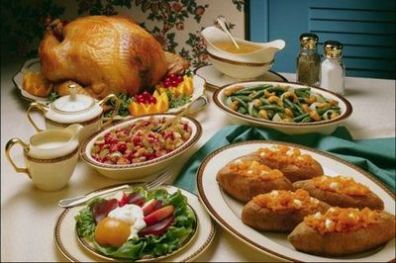
Our WarmesT Wishes for a
HAPPY THANKSGIVING
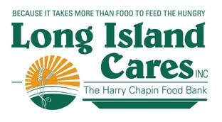
NASSAU COUNTY – Thanksgiving Meals 2016
Name of Agency Address Phone # Day & Time

- Home Mission S/K Naomi Temple A.M.E. Zion Church (516) 623-9340 Saturday, November 19
59 Babylon Turnpike 11:00am-2:00pm
Roosevelt, NY 11575

- Ebenezer SDA S/K 97 Broadway 516-903-3723 Thursday, November 24
Freeport, NY 11520 1:00pm-2:00pm

- The Mary Brennan INN 100 Madison Avenue (516) 486-6243 Thursday, November 24
Hempstead, NY 11550 Serving at 11:30am

- Harvest for the World S/K 90 Pleasant Avenue (516) 623-4498 Thursday, November 24
Roosevelt, NY 11575 Serving at 1:00

- Long Beach Food & Friendship INN 140 West Pine Street (516) 355-6209 Thursday, November 24
Long Beach, NY 11561 11:45am-12:45pm

- First Baptist Church/Westbury 212 Garden St. (516) 333-6668 Thursday, November 24 Westbury, NY 11590 Serving at 11:00am

- First United Methodist S/K 30 Union Place 516-378-5448 Thursday, November 24
Roosevelt, NY 11575 1:00pm-4:00pm

- Faith Mission SK Pope Francis Hospitality 516-992-5063 Thursday, November 24
1510 DePaul St. Serving at 11:30am
Elmont, NY 11003

- Ladles of Hope SK 65 Atlantic Ave. 516-378-0665 Saturday, November 26
Hempstead, NY 11550 Serving at 11:00am

SUFFOLK COUNTY - Thanksgiving Meals 2016
Agency Address Phone # Day & Time
1. St. Gerard Majella Stewardship 300 Terryville Road 631-473-2900 Thursday, November 17 Port Jeff Station, NY 11776 5:30pm-6:00pm
- Serving Our Savior S/K 79 East Main Street (631) 587-5838 x304 Thursday, November 17
Babylon, NY 11702 Serving at 5:30pm

- Shepherds INN S/K St. Joseph’s Carew Hall N/A Friday, November 18
45 Church Street Serving at 6:00pm
Lake Ronkonkoma, NY 11779

- Hospitality Too S/K St. Anne’s Church (631) 482-8538 Saturday, November 19
88 Second Avenue 11:00am-12:00pm
Brentwood, NY 11717

- Our Daily Bread S/K St. James Church (631) 941-4141 Sunday, November 20
429 Route 25A Serving at 3:00pm
Setauket, NY 11733

- Holy Church of Christ S/K 41 Sage Street 631-234-6799 Sunday, November 20
Central Islip, NY 11722 Serving at 2:00pm

- Patchogue Neighbor’s INN #2 St. Paul’s Emergency FP 631-475-3078 Monday, November 21
(Will be serving ham) 31 Rider Ave. 12:00pm-1:00pm
Patchogue, NY 11772

- Nourish Babylon Christ Episcopal Church 631-661-5757 Monday, November 21
12 Prospect St. 5:00pm-7:00pm
Babylon, NY 1170

- The Patchogue Neighbors INN #2 St. Joseph The Worker 516-987-9459 Tuesday, November 22
510 Narragansett Ave. 6:00-6:30pm
E. Patchogue, NY 11772

- Having Friends INN 131 Middle Road (631) 375-2317 Wednesday, November 23
Sayville, NY 11782 Serving at 5:30

- Bethany Hospitality INN 100 Lemon Street (631) 521-6036 Wednesday, November 23
Central Islip, NY 11722 10:30am-11:30

- Invited INN Trinity Lutheran Church (631) 744-8686 Thursday, November 24
716 Route 25A Serving at 1:00pm
Rocky Point, NY 11778

- Federation of Org. Power S/K 456 Waverly Avenue (631) 447-6460 Thursday, November 24
Patchogue, NY 11772 ext. 2114 11:00am-1:00pm

- Mercy INN 17 S. 20th St. (631) 643-5117 Thursday, November 24
Wyandanch, NY 11798 12:00pm-1:00pm

- Love & Mercy SK First Christian Church 631-273-7979 Saturday, November 26
1818 Fifth Ave. 12:00pm-2:00pm
Bay Shore, NY 11706

